RestAssured - Architecture

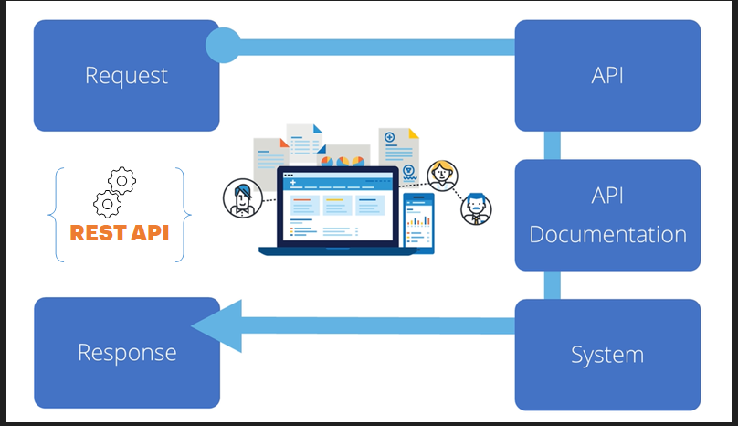

Send the request to the server and validate the response .
Example :
Get

Response Code
200 Ok

Response Body

{"data":{"id":2,"email":"janet.weaver@reqres.in","first_name":"Janet","last_name":"Weaver","avatar":"https://reqres.in/img/faces/2-image.jpg"},"support":{"url":"https://reqres.in/#support-heading","text":"To keep ReqRes free, contributions towards server costs are appreciated!"}}

POST

Arch of RestAssured
How to configure RestAssured in Maven
Sending API requests through RestAssured – Java program
GET
Read the body
Use the get methods
Validate the response

+++++++++++++++++++++++++++++++++

BaseURI
How vcan we handle multiple apis requests

import io.restassured.RestAssured;
import io.restassured.http.ContentType;
import org.testng.annotations.Test;
import static org.hamcrest.Matchers.equalTo;
import static org.hamcrest.Matchers.greaterThan;
import static org.hamcrest.Matchers.greaterThanOrEqualTo;
import static org.hamcrest.Matchers.lessThanOrEqualTo;
import static org.hamcrest.Matchers.lessThan;

public class HamcrestNumberExample {

public String endpoint = "https://restful-booker.herokuapp.com/booking/1";

@Test
public void numberAssertions() {
RestAssured.given().contentType(ContentType.JSON)
.when().get(endpoint).then()
.body("totalprice", equalTo(164));

RestAssured.given().contentType(ContentType.JSON)
.when().get(endpoint)
.then().body("totalprice",greaterThan(100));

RestAssured.given().contentType(ContentType.JSON)
.when().get(endpoint)
.then().body("totalprice",greaterThanOrEqualTo(50));

RestAssured.given().contentType(ContentType.JSON)
.when().get(endpoint)
.then().body("totalprice",lessThan(1000));

RestAssured.given().contentType(ContentType.JSON)
.when().get(endpoint)
.then().body("totalprice",lessThanOrEqualTo(1000));

}

}

POST :

{
"name": "michael",
"job": "faculty"
}

---Response Body for post –

{"name":"michael","job":"faculty","id":"629","createdAt":"2024-02-01T06:21:46.050Z"}

https://reqres.in//api/register

https://reqres.in/api/register
https://reqres.in/

RestAssured.baseURI = "https://reqres.in/";

How to pass the body through code – for

POST ---- Data patterns ---- “{\”fileldName\”:\”value\” ,
\”field1\”:\”value1\”,
}”
DELETE
PUT

PUT :
aseURI : https://reqres.in/
/api/users/2

200

{
"name": "morpheus",
"job": "zion resident"
}

{
"name": "morpheus",
"job": "zion resident",
"updatedAt": "2024-02-01T09:48:14.043Z"
}

Properties properties = new Properties();
FileInputStream input = new FileInputStream("config.properties");
properties.load(input);

// Set base URI
RestAssured.baseURI = properties.getProperty("api.baseurl");

// Set endpoint
String endpoint = properties.getProperty("api.endpoint");

// Set authentication token or other headers if needed
String authToken = properties.getProperty("api.token");

// Execute GET request
Response response = RestAssured.given()
.header("Authorization", "Bearer " + authToken) // Optional header
.get(endpoint);

// Print response
System.out.println("Response Code: " + response.getStatusCode());
System.out.println("Response Body: " + response.getBody().asString());

// Close input stream
input.close();
}

Sample API Casestudie for practice:

https://openweathermap.org/api

https://dummy.restapiexample.com/

https://blazeddemo.com

Body data template : for post/delete/put :
\"eve.holt@reqres.in\"

{\"fildName\":\"value1\"} // single field

{"\email\":\"gayatrimis1@gmail.com\" ,
"\password\":\"school100\",
"\confirmedpasscode\":\"school100\"
}

"{"\email\":\"gayatrimis1@gmail.com\" ,
"\password\":\"school100\",
"\confirmedpasscode\":\"school100\"
}
"

APITesting_Contents_SoapUI_Jan-2024_Gayatri

https://github.com/c11472/-APITesting_Contents_RestAssured_Jan-2024_Gayatri-.git

1. Restassured Archicture
2. Configuring RestAssured in Eclips + Maven
3. First Script to execute Gate method [API]
4. Capturing the response content
5. Validating the response document
6. POST method , accept the body details through code
7. PUT to update the details - script
8. DELETE method - script
9. Assert in RestAssured
10.0 Data driven testing using properties file
10.0 Maintaining multiple configuration files for BaseURI , EndPOint , API Body for Post and Delete methods
10. Sample Framework- api testing [Without TestNG]
11. Sample Framework – RestAssured – API Testing with TestNG and Maven

